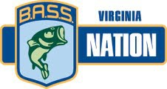
2021 SUMMER CLASSIC (Formerly Team Championship

ENTRY FEES:

Kerr Lake, Occoneechee State Park Ramp

April 17-18, 2021

ENTRY DEADLINE: April 10, 2021 (after deadline date add $10 late fee per club)

$140 per team – TEAM ENTRY ONLY
(A copy of each boat owners insurance must accompany entry form and fee)

Mail entry form & fee to: Make check payable to BNVA Pam Bryant
461 Triangle School Road
Chatham, VA 24531

PRE TOURNAMENT INFORMATION
REGISTRATION DATES Thursday, April 15, 2021 (8am-8pm) & Friday, April 16, 2021 (8am-11am) Call Pam Bryant at (276) 634-6039

Anyone not registered by phone with Pam Bryant by

REGISTRATION REMINDER

TOURNAMENT HEADQUARTERS
Friday, April 16, 2021 at 11 am will be disqualified for the tournament.

Magnuson Motel, Clarksville, VA
434-374-5023

Lake Motel, Clarksville, VA 434-374-8106
TOURNAMENT SITE Blast off and weigh-in
Occoneechee State Park Ramp

TOURNAMENT MEETING:

Friday, April 16th, at 5:00PM at the Magnuson Motel
All team members must be present

BOAT INSPECTION

FISH MINIMUM SIZE LIMIT
There will be a boat inspection at blast off.

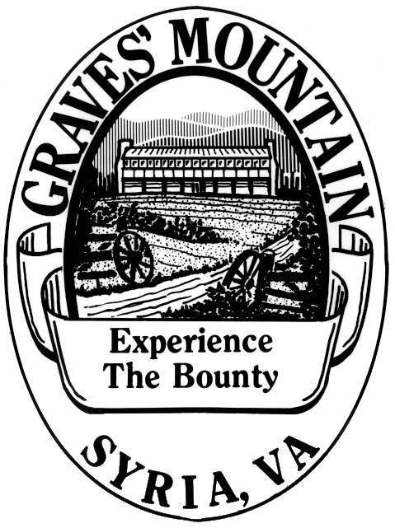
5 fish limit and lake size: 2-12" & 3-14" for Kerr Lake

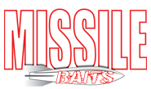

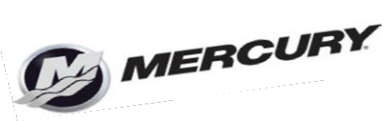
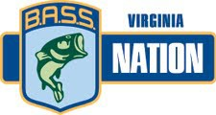

2021 SUMMER CLASSIC
(Formerly Team Championship)

April 17-18, 2021

Occoneechee State Park, Kerr Lake

Tournament Entry Form:

Club: Region: _

Boat Owner- | Cell #-
Non-Boater- | Cell #-
Boat Owner- | Cell #-
Non-Boater- | Cell #-
Boat Owner- | Cell #-
Non-Boater- | Cell #-
Boat Owner - | Cell# -
Non-Boater - | Cell# -
Boat Owner- | Cell #-
Non-Boater- | Cell #-
Boat Owner- | Cell #-
Non-Boater- | Cell #-
Boat Owner - | Cell #-
Non-Boater- | Cell #-
Boat Owner- | Cell #-
Non-Boater- | Cell #-
Boater- | Cell# -
Non-Boater- | Cell #-
Boater - | Cell #-
Non-Boater- | Cell #-

This event is a state qualifier. To be eligible you must be an active member of the B.A.S.S. Nation of VA Inc.

