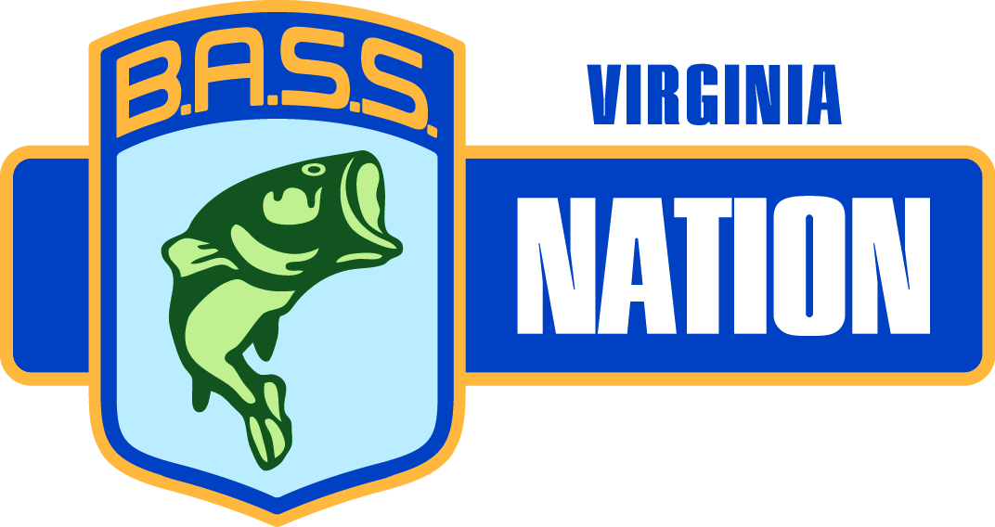
Minutes for Board Meeting
January 13, 2019

Call to order – 9:00AM by Mike Bryant by Conference Call.
Roll Call
    - Region 1 Scott Favors
    - Region 2 Charlie Davis
    - Region 3 Cavin Young
    - Region 4 Stephen Davis
    - Region 5
    - Region 6 Chris Merritt
    - Region 7 Sid Ryan
    - Region 10
    - Casting Kids Mike Boitnott
    - Youth Jack Babcock
    - Vice Pres Steve Woodroof
    - Conservation Joan Blankenship

- Minutes – motion to approve by Scott Favors and second by Stephen Davis. All approved

- Treasurer’s report – Hold til next meeting.

Old Business: WEBSITE: vabassnation.com - Tell your clubs

- 2018 BNC - Nov. 8-10, 2018 – Jeff Lugar (10th) & Travis Lugar (7th) will represented VA at the BNC

- State Team Raffle - Sell tickets again this year. Regions have to sell and state team members sell 10 each.
- July 1-4 and 8-12, 2019 to draw and return by June 23, 2019. Hand out at Richmond Show.

Alliance Program 2018 Triton; Mercury; Lowrance, Motorguide, – Good for 2019
Lowrance contract 2019 - State Team only get discount
We now have to help sell Triton Boats to get up to $5000 - no longer free
State Sponsors Conrad Enterprise – Clarksville raffle; discount rate; comp rooms
South Hill Chamber of Commerce - $ per room per night
. Zebco – 50 rods for youth and discount purchase for state team from Quantum BNC
ReyChem (Detailer’s Choice) – Giveaways
Glass Baron – Glass for raffle
Power Pole
Real Deal Props – Discount service on props & trolling motors for giveaways
River Rat Baits – Baits for each state event & 25% discount to all members
Missile Baits – Lures for state events
Graves Mountain Lodge – Sample jelly and weekend giveaway
TH Marine – 40% off for State Team & Board members
Angler’s Choice Marine
Aftco – Conservation discount products
New Business:

- Region Director - Changes – No changes for this upcoming year.

- 2019 Calendar -Revised and emailed to board members
- January 18-20, 2019 Richmond Fishing Expo – Need workers
- January 25-26, 2019 – Angler’s Choice Marine Open House (HS anglers hold Casting kids)

- Region Calendars - Send me your schedule for Tournament Central

- State Team Packets - Will mail after we get Alliance info. From BASS (They are restructuring)

- College Championship - Scheduled and discussion of another date. No changing of dates.

- Entry Forms - Attached – Team Championship
- Mr. BASS looking for a place for the meeting

- 2019 Budget - Any questions or changes - None

- Giveaways - We need help getting items for the tournaments and goody bags. Scott 4 gallons of boat cleaner

- Conservation - Report attached - AFTCO gives 10% of sales to conservation – Purchase items
- A lot of discussion about growing the grass at VT and grants to fund it.
- Also working on a plan to put some grass at SML by the end of May 2019. Dan Wilson is the lead on the SML project. Staunton River HS is the closest school to help. May be able to get the left-over cages to help.

FACEBOOK - Send pictures to Abby Ryan to post. All items have to be in jpg.
Delete any competing organizations schedules.

Report from Region Directors & Casting Kids & Conservation & Tournament

Region 1 – Schedule posted and on webpage. Coverage for Richmond Show. New Big Bass Jr. Championship.
Region 2 – Sent schedule for this year. Can you help with the College Championship? Yes.
Region 3 - Schedule set and next meeting is January 21.
Region 4 – Waiting to see if Region 5 will fish together to make the tournament larger.
Region 5 – Restructure
Region 6 – Schedule set and fishing again with region 3.
Region 7 – 1st event is March 10. Three new trails started in their area. Do not know how it will affect them. The tournaments are the same day as the region.
Region 10 –
Youth – Getting ready for the Richmond show and John Crews awards. Raffle tickets sent to Jack to sell.
VP – Will get raffle tickets printed for the adult clubs.
Casting Kids – Nothing at this time until September.

- Motion to adjourn by Joan Blankenship and second by Sid Ryan. All approved.

Next board meeting – March 10, 2019 at 9:00AM, Pizza Pub, Clarksville, VA

