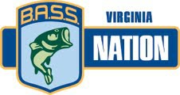

ENTRY FEES:

Kerr Lake, Occoneechee State Park Ramp

May 18-19, 2019
2019 TEAM CHAMPIONSHIP

ENTRY DEADLINE: May 5, 2019 (after deadline date add $10 late fee per club)

$140 per team – TEAM ENTRY ONLY
(A copy of each boat owners insurance must accompany entry form and fee)

Mail entry form & fee to: Make check payable to BNVA Pam Bryant
461 Triangle School Road
Chatham, VA 24531

PRE TOURNAMENT INFORMATION
REGISTRATION DATES Thursday, May 16, 2019 (8am-8pm) & Friday, May 17, 2019 (8am-11am) Call Pam Bryant at (276) 634-6039

Anyone not registered by phone with Pam Bryant by

REGISTRATION REMINDER

TOURNAMENT HEADQUARTERS
Friday, May 17, 2019 at 11 am will be disqualified for the tournament.

Lake Motel, Clarksville, VA
434-374-8106

Magnasun Motel, Clarksville, VA 434-374-0900
TOURNAMENT SITE Blast off and weigh-in
Occoneechee State Park Ramp

TOURNAMENT MEETING:

Friday, May 17th, at 5:00PM at the Community Center
All team members must be present

BOAT INSPECTION

FISH MINIMUM SIZE LIMIT
There will be a boat inspection at blast off.

5 fish limit and lake size: 2-12" & 3-14" for Kerr Lake

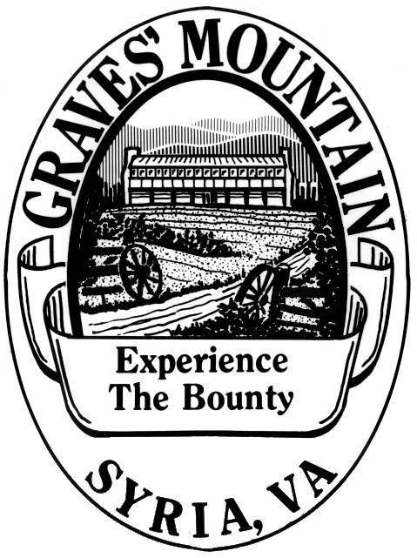

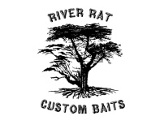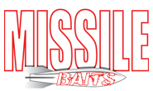

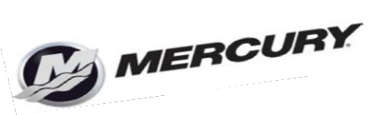
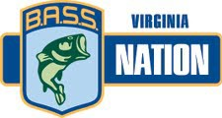

2019 Team Championship

May 18-19, 2019

Occoneechee State Park, Kerr Lake

Tournament Entry Form:

Club: Region: _

Boat Owner- | Cell #-
Non-Boater- | Cell #-
Boat Owner- | Cell #-
Non-Boater- | Cell #-
Boat Owner- | Cell #-
Non-Boater- | Cell #-
Boat Owner - | Cell# -
Non-Boater - | Cell# -
Boat Owner- | Cell #-
Non-Boater- | Cell #-
Boat Owner- | Cell #-
Non-Boater- | Cell #-
Boat Owner - | Cell #-
Non-Boater- | Cell #-
Boat Owner- | Cell #-
Non-Boater- | Cell #-
Boater- | Cell# -
Non-Boater- | Cell #-
Boater - | Cell #-
Non-Boater- | Cell #-

This event is a state qualifier. To be eligible you must be an active member of the B.A.S.S. Nation of VA Inc.

